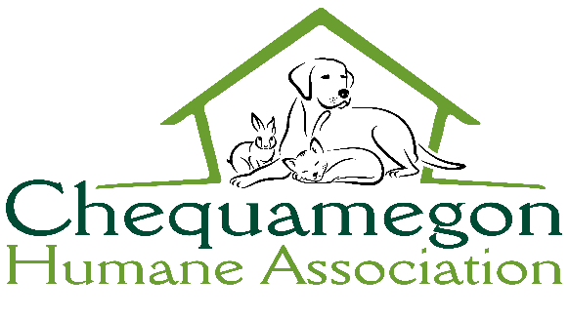

To Whom it May Concern,
This letter is to inform you that as of //2021, has completed Hours of volunteer work at the Chequamegon Humane Association.
If you have any questions or concerns, please contact us at:
Chequamegon Humane Association
cheqhumane@gmail.com
P.O. Box 93
Ashland, WI 54906
715-682-9744

Thank you,

Annie DeSimone
Volunteer/ Outreach Coordinator
Chequamegon Humane Association

